Wesham Town Council Monthly Meeting to be held on Tuesday, 12th December 2023
at 7.00pm in the Committee Room, Wesham Community Centre.

AGENDA

APOLOGIES: Cllrs P Desmond

CODE OF CONDUCT AND STANDING ORDERS
Members are reminded of the standard of conduct they must adhere to during Town Council meetings.

DECLARATION OF INTERESTS:
Members are reminded that any direct or indirect pecuniary or other interests should be declared as required by the Council’s Code of Conduct for Members.

23/111 APPROVAL OF THE MINUTES
OF THE COUNCIL MEETING HELD 21st November 2023
23/112 MATTERS ARISING – any item not covered by agenda or action list

23/113 POLICING ISSUES -
- Crime Reports – police.org.uk website > area > PR4 3DR (WCC postcode)
- Policing Issues – to discuss any items raised by Councillors

Update on Policing information – Cllr Doug Nowell

23/114 PLANNING -
- Planning Applications –

23/0799 – Unrestricted Occupation – Woodside, Medlar Lane, Wesham

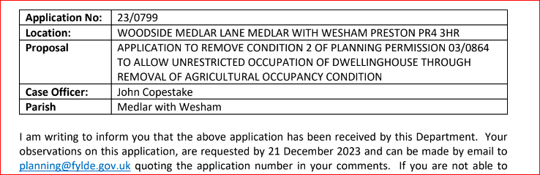

- Mill Farm - Public Meeting ? Post meeting review

23/115 PLAYING FIELDS and OPEN SPACES – any urgent items?

23/116 HIGHWAYS AND RAILWAYS – any urgent items?

23/117 GOVERNANCE, FINANCE AND INSURANCE

Accounts payable and income received report –

WTC Monthly summary – Nov 2023

Unity Trust Bank Transfer update

Accident and Incident Reporting – none

23/118 EVENTS -
New Year’s Eve Family evening – WCC event

23/119 HUMAN RESOURCES
- HR sub-committee – update?
- WTC TC advert – appointment ?

23/120 WESHAM COMMUNITY CENTRE - Note: BAU @ WCC meetings
- Update Report from WCC manager
- Any urgent updates

23/121 OTHER
- LALC membership
- Printer update
- Website
- Actions

DATE OF NEXT WTC monthly meeting: – 16th Jan 2023

WTC Meetings
Date | Meeting
12th Dec 2023 | WTC Monthly meeting
16th Jan 2024 | WTC Monthly meeting
?? Jan 2024 | Finance Meeting ( 2nd Precept discussion)

Angela Hunter Date: 6th December 2023

